- Black and Green theme with futuristic look

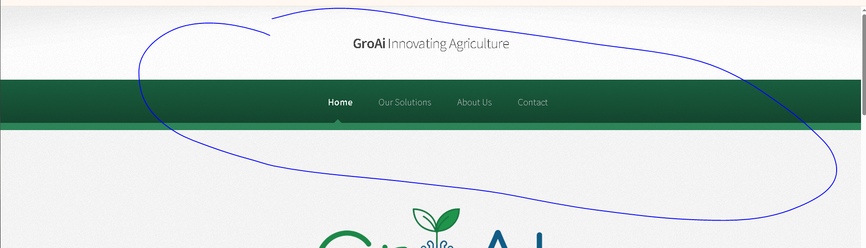
- - The headlines I keep them but under Our Solutions system packages I want to add Cloud/Remote Access and Care/Consultancy
- About us: Remove the hoogendoorn name from it and just keep agricultural experience

- Under blog we can put some news
- I had commissioned more than 50 farms so that can be added to the experience
- Remove anything that is necessary
- Remove all social media, Linkedin page will be added later
- Blog I don’t know if you can link it to the agricultural news in North America and Middle East
- The messege that i sent link it to info@groai.ca and mustafa_attwan@live.com
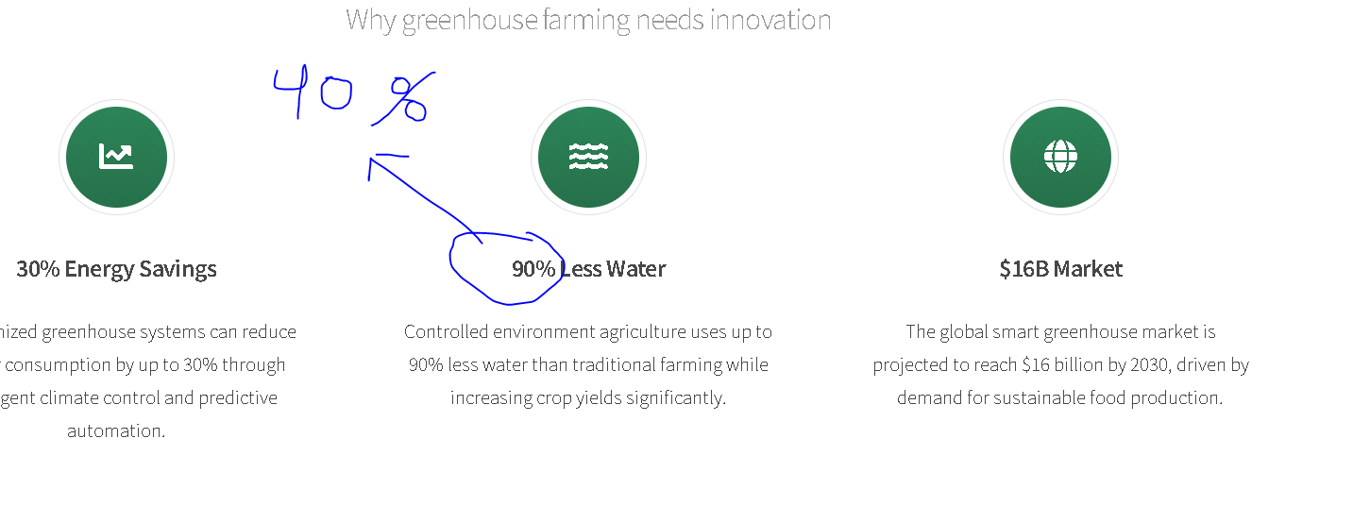
- Between 40% to 80% water saving
- 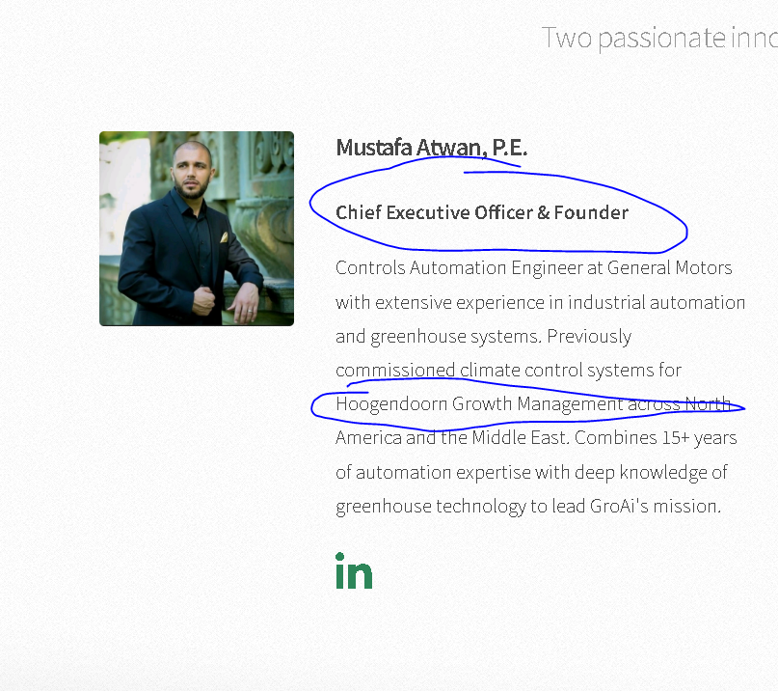

- Remove Hoogendoorn and put high tech company with 50+ farms across North America and Middle East. You can make it pretty
- Also you can add Founder/CEO, not whats there too long
- Remove all that
